FinTrust Financial Intelligence & Digital Banking Support Solution
Week 1: Business & Data Intelligence Assessment
Data Analytics Track
Item | Detail
Prepared by | Lihamole Thapeliso
Track | Data Analytics
Data reviewed | FinTrust Customer Data (1,500 records) and FinTrust Transaction Data (12,000 records), 1 Jan to 31 Mar 2026
Tools used | SQL (profiling and analysis); Excel/Power BI planned for dashboard build
Deliverables | 1 Business Understanding · 2 Data Profiling Report · 3 Analytical Questions · 4 KPI Definition Table · 5 Dashboard Wireframe · 6 Initial Analysis Plan

1. Business Understanding

1.1 The business problem
FinTrust Digital Bank wants to use data, machine learning and generative AI to understand customer and transaction behaviour, support risk-related decisions, improve operations and strengthen digital customer support. At present, customer and transaction records exist as separate flat files, with no single view that shows management who is transacting, through which channels, where payments fail and which activity attracts risk review.

1.2 Why the problem is important
- Growth and engagement: 65.5% of transactions already run through digital channels (Mobile App, Web, USSD), so digital experience directly affects customer activity and value.
- Customer experience: 8.0% of transactions are failed or reversed, which is customer friction and lost value that management should track.
- Risk and compliance: 19.6% of transactions carry a risk-review flag. Review capacity is limited, so the bank needs to know where flagged activity concentrates.
- Operational focus: without clear KPIs, teams cannot prioritise channels, segments or cities for investment or fixes.

1.3 How the Data Analytics track contributes
Data Analytics builds the foundation layer for the rest of the project: profiling and documenting the data, turning it into a defined set of KPIs, answering the core business questions in SQL, and presenting the results in a dashboard. These outputs give the Data Science track candidate features and context for the risk-review label, and give the AI-assistant track verified facts about channels, failures and customer behaviour.

1.4 Outputs this track can provide
- A data profiling and data-quality report
- A KPI framework with baseline values
- Reusable SQL queries and views (customer-level and transaction-level)
- An interactive dashboard (Power BI) covering overview, customers, channels and risk review
- A written summary of insights and recommendations for management

1.5 Business questions management should be able to answer
- How much is being transacted, how many transactions occur, and how is this trending month to month?
- Which customer segments, cities and income bands drive the most transaction value?
- Which channels and transaction types carry the most volume and value?
- How reliable are transactions? What share fail, reverse or stay pending, and where?
- Are more digitally engaged customers more active?
- Where does risk-review activity concentrate (channel, type, amount, international)?
- Are dormant or restricted accounts still transacting?
- Is the data reliable enough to support the AI and ML work in later weeks?

1.6 Decisions the analysis can support
Decision | Supported by
Where to invest in digital channels or fix reliability problems | Channel volume, value and failure/reversal rates
Which customer segments or cities to target with campaigns | Value and activity by segment, city and income band
Where to focus risk-review effort and staffing | Flag rates by type, amount band, channel and international status
Whether controls on dormant and restricted accounts are working | Transactions on non-active accounts
What data fixes are required before ML modelling | Profiling results and data-quality issue log

1.7 Stakeholders who benefit
Stakeholder | How they benefit
Executive management | Clear KPIs on activity, value, reliability and risk exposure
Digital product / channel teams | Channel performance and failure hot spots to prioritise improvements
Risk and compliance | Patterns in flagged activity to guide review effort
Operations and customer support | Failure, reversal and pending patterns that drive customer contacts
Marketing / customer value management | Segment, city and income-band behaviour for targeting and retention
Data Science and AI project tracks | Clean, documented data and validated business context

2. Resources Reviewed
Resource | What it contains | How I will use it | Limitations identified
FinTrust Customer Data (CSV) | 1,500 customers: demographics, city, segment, account type, tenure, engagement score, income band, preferred channel, account status | Customer dimension for segment, city, income and status analysis; joined to transactions on Customer_ID | No transaction history or balances. Segment does not align with age or income (see Section 3.7). Contains customer names, which are personal data and should be excluded from outputs.
FinTrust Transaction Data (CSV) | 12,000 transactions from 1 Jan to 31 Mar 2026: type, amount (NGN), channel, device, location, international flag, status, risk-review flag | Fact table for volume, value, channel, status and risk-review analysis | Only 3 months. No debit/credit direction. Device and location fields are unreliable. Timestamps are stored as text. Risk_Review_Flag is synthetic.
Project brief (Week 1) | Track tasks, deliverables and definitions of success | Defines scope: profiling, analytical questions, KPIs, wireframe and plan | No formal cross-track collaboration in Week 1
SQL, Excel, Power BI | Analysis and visualisation tools | SQL for profiling and analysis, Excel for checks, Power BI for the Week 3 dashboard | Dashboard build is not required in Week 1

3. Data Understanding and Profiling Report

3.1 Dataset overview
Dataset | Records | Columns | Primary key | Grain
Customer data | 1,500 | 12 | Customer_ID (no duplicates) | One row per customer
Transaction data | 12,000 | 11 | Transaction_ID (no duplicates) | One row per transaction

3.2 Customer data: field dictionary
Field | Data type | Category | Values / range
Customer_ID | Text | Identifier (key) | 1,500 unique IDs
Customer_Name | Text | Identifier (personal data) | Free text
Age | Integer | Numerical | 18 to 65 (mean 41.6)
Gender | Text | Categorical | Male 727, Female 722, Prefer not to say 51
City | Text | Categorical | Lagos 488, Abuja 223, Port Harcourt 172, Kano 159, Ibadan 148, Enugu 108, Kaduna 103, Benin City 99
Customer_Segment | Text | Categorical | Everyday 711, Premium 295, Student 278, SME 216
Account_Type | Text | Categorical | Savings 893, Current 378, Premium 229
Tenure_Months | Integer | Numerical | 1 to 96 (mean 49.9)
Digital_Engagement_Score | Decimal | Numerical | 16.7 to 100 (mean 68.0)
Monthly_Income_Band | Text | Categorical (ordered) | Below 100k 265, 100k-249k 430, 250k-499k 416, 500k-999k 255, 1m+ 134
Preferred_Channel | Text | Categorical | Mobile App 924, Web 357, USSD 219
Account_Status | Text | Categorical | Active 1,367, Dormant 107, Restricted 26

3.3 Transaction data: field dictionary
Field | Data type | Category | Values / range
Transaction_ID | Text | Identifier (key) | 12,000 unique IDs
Customer_ID | Text | Identifier (foreign key) | Links to customer data
Transaction_DateTime | Text (M/D/YYYY H:mm) | Date/time | 1 Jan 2026 00:00 to 31 Mar 2026 23:59
Transaction_Type | Text | Categorical | Transfer 3,549, Card Purchase 3,033, Bill Payment 1,475, Cash Withdrawal 1,430, Deposit 1,328, Airtime/Data 1,185
Amount_NGN | Decimal | Numerical | ₦100.17 to ₦693,454.45 (median ₦10,306; mean ₦46,706)
Channel | Text | Categorical | Mobile App 5,102, POS 2,393, Web 1,869, ATM 1,747, USSD 889
Device_Type | Text | Categorical | Android 4,797, iOS 2,920, POS Terminal 1,571, Web Browser 1,447, ATM Terminal 1,169; 96 missing
Location | Text | Categorical | 8 cities, 1,431 to 1,550 each; 96 missing
International_Transaction | Text | Categorical (Yes/No) | No 11,520, Yes 480
Transaction_Status | Text | Categorical | Successful 10,856, Failed 630, Reversed 326, Pending 188
Risk_Review_Flag | Text | Categorical (Yes/No) | No 9,648, Yes 2,352 (19.6%)

3.4 Relationship between the datasets
The datasets have a one-to-many relationship: one customer to many transactions, joined on Customer_ID. Checks confirmed there are no orphan transactions (0 transactions without a matching customer) and no customers without transactions (0). Every customer has between 1 and 20 transactions, an average of 8.0.

3.5 Missing values
Table | Field | Missing | Share of rows | Comment
Transactions | Device_Type | 96 | 0.8% | Spread across all channels (e.g. 42 Mobile App, 23 POS, 14 Web, 11 ATM, 6 USSD)
Transactions | Location | 96 | 0.8% | Only 4 rows are missing both, so 188 rows (1.6%) have at least one missing
Transactions | All other fields | 0 | 0% | Complete
Customers | All fields | 0 | 0% | Complete. 'Prefer not to say' in Gender (51) is a valid answer and not a missing value

3.6 Summary of numeric fields
Field | Min | Median | Mean | 95th pct | 99th pct | Max
Amount_NGN (₦) | 100 | 10,306 | 46,706 | 227,286 | 410,905 | 693,454
Age | 18 | 42 | 41.6 |  |  | 65
Tenure_Months | 1 | 51 | 49.9 |  |  | 96
Digital_Engagement_Score | 16.7 | 68 | 68.0 |  |  | 100

Amount_NGN is strongly right-skewed: the mean is more than four times the median, and 5% of transactions are above about ₦227k. Medians and percentile bands are more informative than averages for this field.

3.7 Data-quality issues identified
# | Issue | Evidence | Impact / planned action
1 | Missing Device_Type and Location | 96 rows each (0.8%) | Low impact. Label as 'Unknown' in Week 2 and keep the rows
2 | Device_Type contradicts Channel | Only 176 of 1,747 ATM transactions (10%) show an ATM Terminal; only 324 of 2,393 POS transactions (14%) show a POS Terminal; Mobile App transactions include POS Terminal (618) and ATM Terminal (524) devices | Device-based analysis is unreliable. Use Channel as the primary field and treat Device_Type with caution
3 | Transaction Location appears random | Location matches the customer's home city in 12.7% of transactions, close to the 12.5% expected from a random pick among 8 cities | Do not build location-mismatch or travel-risk analysis on this field
4 | Preferred_Channel does not predict actual channel | Customers who prefer USSD use USSD for only 7.5% of their transactions; Mobile App preferrers use it for 42.5%, the same as the overall mix | Preferred_Channel has weak analytical value
5 | Transaction_DateTime stored as text | Format M/D/YYYY H:mm | Convert to a timestamp before time analysis
6 | Time patterns are artificially uniform | Exactly 500 transactions in every hour of the day | Peak-hour analysis will not be informative. Note as a synthetic-data limitation
7 | Right-skewed Amount_NGN with large values | Median ₦10k, max ₦693k | Use medians and bands. Review outliers before modelling
8 | No debit/credit direction | Deposits and Transfers are all positive amounts | Value is 'gross transaction value', not net flow
9 | Customer segment does not match age or income | Student segment ranges from age 18 to 65 (average 40); 24 Student customers earn 1m+ | Segment labels are synthetic. Interpret with care
10 | Overlapping 'Premium' labels | Premium is both a Customer_Segment and an Account_Type; only 47 of 295 Premium-segment customers hold a Premium account | Document clearly to avoid confusion in reports
11 | Dormant and Restricted accounts still transact | 1,090 transactions (9.1%) from 133 customers, including 989 successful ones | Possible control gap or data inconsistency. Investigate in Week 2
12 | Personal data present | Customer_Name column | Exclude from dashboards and shared outputs
13 | Risk_Review_Flag is a synthetic label | 19.6% flagged; 78.6% of customers have at least one flagged transaction | Not a fraud determination. Present as 'review flag' only

4. Analytical Questions and Initial Results
Seven questions covering customer behaviour, transaction activity, value, channels, status and risk. Each was answered with SQL on the raw data (queries in Appendix A). Results are initial and uncleaned, as the brief asks.

4.0 Headline findings
- Overall: 12,000 transactions worth ₦560.5M over Q1 2026 from all 1,500 customers (8.0 per customer). Average ₦46,706, median ₦10,306.
- Value is concentrated in Transfers and Deposits: Transfers are 29.6% of transactions but 42.4% of value; Deposits are 11.1% of transactions but 23.4% of value.
- Digital channels carry 65.5% of activity: Mobile App alone is 42.5%.
- Reliability: 90.5% successful, 5.3% failed, 2.7% reversed, 1.6% pending. Differences between channels are small (failure 4.2% on ATM to 5.8% on Mobile App).
- Risk review flags: highest for Transfers (28.5%), Cash Withdrawals (25.3%), international transactions (36.9%) and amounts of ₦200k and above (40.5%).
- Engagement score shows no clear link to activity: low, medium and high engagement customers average 7.8, 8.0 and 8.1 transactions.
- Non-active accounts transact: 9.1% of transactions come from Dormant or Restricted accounts.
- Monthly volume per day is flat (about 133 transactions a day), and value per day rose about 4% from January to March.

Q1. Which customer segments, cities and income bands generate the most transaction value?
Why it matters: guides targeting, retention and channel investment.
Segment | Transactions | Value | Share of value | Avg amount
Everyday | 5,644 | ₦261.5M | 46.6% | ₦46,325
Premium | 2,361 | ₦107.8M | 19.2% | ₦45,638
Student | 2,289 | ₦107.5M | 19.2% | ₦46,953
SME | 1,706 | ₦83.8M | 15.0% | ₦49,116

City | Transactions | Value | Share of value | Avg amount
Lagos | 3,911 | ₦189.9M | 33.9% | ₦48,553
Abuja | 1,710 | ₦83.6M | 14.9% | ₦48,878
Port Harcourt | 1,425 | ₦63.9M | 11.4% | ₦44,847
Kano | 1,286 | ₦60.6M | 10.8% | ₦47,111
Ibadan | 1,177 | ₦56.0M | 10.0% | ₦47,587
Enugu | 878 | ₦40.1M | 7.1% | ₦45,635
Kaduna | 830 | ₦35.7M | 6.4% | ₦43,015
Benin City | 783 | ₦30.7M | 5.5% | ₦39,248

Finding: the Everyday segment produces 46.6% of value, mainly because it is the largest segment (47% of all transactions); average amounts are similar across segments (₦45.6k to ₦49.1k), with SME highest. Lagos (33.9%) and Abuja (14.9%) together produce 48.8% of value. Benin City has the lowest average amount (₦39.2k). By income band, 250k-499k (28.4%) and 100k-249k (27.5%) contribute the most value; the Below 100k band has the highest average amount (₦49.5k), which is counter-intuitive and reflects the synthetic nature of the data.

Q2. Which transaction types and channels carry the most volume and value?
Why it matters: shows what customers use the bank for and which channels to prioritise.
Transaction type | Transactions | Value | Share of value | Avg amount
Transfer | 3,549 | ₦237.9M | 42.4% | ₦67,038
Deposit | 1,328 | ₦131.0M | 23.4% | ₦98,633
Card Purchase | 3,033 | ₦85.9M | 15.3% | ₦28,310
Cash Withdrawal | 1,430 | ₦67.8M | 12.1% | ₦47,393
Bill Payment | 1,475 | ₦28.2M | 5.0% | ₦19,094
Airtime/Data | 1,185 | ₦9.8M | 1.7% | ₦8,250

Channel | Transactions | Share of txns | Value | Avg amount
Mobile App | 5,102 | 42.5% | ₦240.1M | ₦47,061
POS | 2,393 | 19.9% | ₦104.3M | ₦43,605
Web | 1,869 | 15.6% | ₦89.3M | ₦47,793
ATM | 1,747 | 14.6% | ₦83.9M | ₦48,049
USSD | 889 | 7.4% | ₦42.8M | ₦48,098

Finding: Transfers dominate value (₦237.9M, 42.4%). Deposits have the highest average amount (₦98.6k), while Airtime/Data is the smallest (₦8.3k average, ₦9.8M total). Mobile App leads on volume (42.5%) and value (₦240.1M). USSD is the smallest channel (7.4% of transactions). Every channel has a similar transaction-type mix, with Transfers first in each.

Q3. How do transaction volume and value trend over time?
Why it matters: shows growth and helps planning and target-setting.
Month | Transactions | Value | Transactions per day | Value per day
2026-01 | 4,133 | ₦188.5M | 133 | ₦6.1M
2026-02 | 3,734 | ₦175.8M | 133 | ₦6.3M
2026-03 | 4,133 | ₦196.2M | 133 | ₦6.3M

Finding: February appears lower only because it has fewer days. Daily volume is flat at about 133 transactions, while daily value grew from ₦6.08M (January) to ₦6.33M (March), about 4%. Hour-of-day and day-of-week views are almost perfectly uniform (500 transactions in every hour), which is unusual for real banking data, so peak-time analysis will add little value. This is recorded as a synthetic-data limitation.

Q4. How often do transactions fail, reverse or stay pending, and does it differ by channel?
Why it matters: failed and reversed transactions mean customer friction and operational cost.
Channel | Transactions | Failed | Reversed | Pending
Mobile App | 5,102 | 5.8% | 2.8% | 1.6%
USSD | 889 | 5.4% | 3.3% | 1.0%
POS | 2,393 | 5.2% | 2.5% | 1.4%
Web | 1,869 | 4.7% | 2.4% | 2.0%
ATM | 1,747 | 4.2% | 2.7% | 1.4%

Finding: overall 5.3% fail, 2.7% reverse and 1.6% stay pending (8.0% failed or reversed). Mobile App has the highest failure rate (5.8%) and ATM the lowest (4.2%), while USSD has the highest reversal rate (3.3%) and Web the highest pending rate (2.0%). By transaction type, Bill Payment fails most (5.8%) and Airtime/Data reverses most (3.6%). The gaps are small, so these are areas to monitor and test in Week 2 rather than firm conclusions. Mobile App matters most because it carries the largest volume (about 296 failures).

Q5. Do more digitally engaged customers transact more?
Why it matters: tests whether the engagement score is useful for targeting and for later modelling.
Engagement band | Customers | Avg transactions | Avg total value
Low (<50) | 237 | 7.8 | ₦348,730
Medium (50-74) | 712 | 8.0 | ₦379,888
High (75+) | 551 | 8.1 | ₦376,312

Finding: there is almost no difference in activity across engagement bands (7.8, 8.0 and 8.1 transactions). Medium and High engagement customers have slightly higher total value than Low (₦376k to ₦380k vs ₦349k). Digital_Engagement_Score does not appear to be a strong driver of activity in this dataset.

Q6. Which transactions are flagged for risk review, and how do type, amount, channel and international status relate to the flag?
Why it matters: helps risk teams focus review effort and gives the Data Science track a starting point. Overall 2,352 of 12,000 transactions (19.6%) are flagged.
Transaction type | Transactions | Flagged | Flag rate
Transfer | 3,549 | 1,011 | 28.5%
Cash Withdrawal | 1,430 | 362 | 25.3%
Deposit | 1,328 | 215 | 16.2%
Airtime/Data | 1,185 | 180 | 15.2%
Card Purchase | 3,033 | 395 | 13.0%
Bill Payment | 1,475 | 189 | 12.8%

Amount band | Transactions | Flagged | Flag rate
Under 10k | 5,947 | 1,050 | 17.7%
10k-50k | 3,110 | 554 | 17.8%
50k-200k | 2,208 | 450 | 20.4%
200k+ | 735 | 298 | 40.5%

- International: 36.9% flagged (177 of 480) vs 18.9% for domestic (2,175 of 11,520).
- Status: Failed transactions are flagged 27.0% of the time vs 19.2% for Successful, 18.4% Reversed and 17.6% Pending.
- Channel: Web (21.3%) and ATM (21.2%) are highest; USSD (17.3%) is lowest. The spread is modest.
- Segment: flag rates are almost identical across segments (19.3% to 20.3%).
- Amount: flagged transactions average ₦68,786 vs ₦41,324 for non-flagged.
- Customers: 78.6% of customers have at least one flagged transaction, and 21.1% have three or more.
Finding: the flag is strongly associated with Transfers, Cash Withdrawals, international activity and large amounts (40.5% flagged at ₦200k and above), and only weakly with channel or segment. These are associations in a synthetic label, not proof of fraud. They give the Data Science track candidate features to test.

Q7. Are Dormant or Restricted accounts still transacting?
Why it matters: activity on non-active accounts may indicate control gaps or data inconsistencies.
Account status | Customers | Transactions | Value | Share of txns
Active | 1,367 | 10,910 | ₦510.9M | 90.9%
Dormant | 107 | 866 | ₦38.7M | 7.2%
Restricted | 26 | 224 | ₦10.9M | 1.9%

Finding: all 107 Dormant and 26 Restricted customers have transactions. Together they account for 1,090 transactions (9.1%) worth ₦49.6M (8.9%), and 989 of those succeeded. Dormant and restricted customers transact at about the same rate as active ones (8.1 and 8.6 transactions per customer vs 8.0). Either the status field is not current, or the accounts are not properly controlled; this should be raised with stakeholders and checked in Week 2.

5. KPI Planning
KPI | Definition | Why it matters | Required data
Total transaction value | Sum of Amount_NGN over the period | Measures overall activity and business scale | Amount_NGN, Transaction_DateTime
Transaction success rate | Successful transactions ÷ total transactions | Measures service reliability and customer experience | Transaction_Status
Failure + reversal rate | (Failed + Reversed) ÷ total transactions | Shows customer friction and operational cost | Transaction_Status, Channel
Risk review rate | Transactions with Risk_Review_Flag = Yes ÷ total transactions | Shows the size of review workload and risk exposure | Risk_Review_Flag, Amount_NGN, Transaction_Type
Digital channel share | Mobile App + Web + USSD transactions ÷ total transactions | Tracks digital adoption | Channel
International transaction share | International_Transaction = Yes ÷ total transactions | Tracks the higher-risk cross-border mix | International_Transaction, Risk_Review_Flag
Average transactions per customer | Total transactions ÷ distinct customers | Measures customer engagement | Customer_ID, Transaction_ID

Baseline KPI values (Q1 2026)
KPI | Baseline value
Total transaction value | ₦560.5M (₦560,477,355)
Total transactions | 12,000
Transaction success rate | 90.5%
Failure + reversal rate | 8.0% (failed 5.3%, reversed 2.7%)
Risk review rate | 19.6%
Digital channel share | 65.5%
International transaction share | 4.0%
Average transactions per customer | 8.0

6. Dashboard Wireframe
The dashboard has four pages. Each page carries the same global filters (date range, segment, city, channel, transaction type, status), with page-specific filters where relevant. Values shown in the wireframes are the Q1 2026 baselines and are illustrative of layout; the charts are placeholders to be built in Power BI in Week 3.

Page 1: Executive Overview
Management sees total value, volume, reliability, risk and digital share at a glance, with a monthly trend, value by transaction type, and channel share.
Expect to show: Transfers and Deposits drive most of the value, Mobile App leads volume, and daily value is trending up slightly.
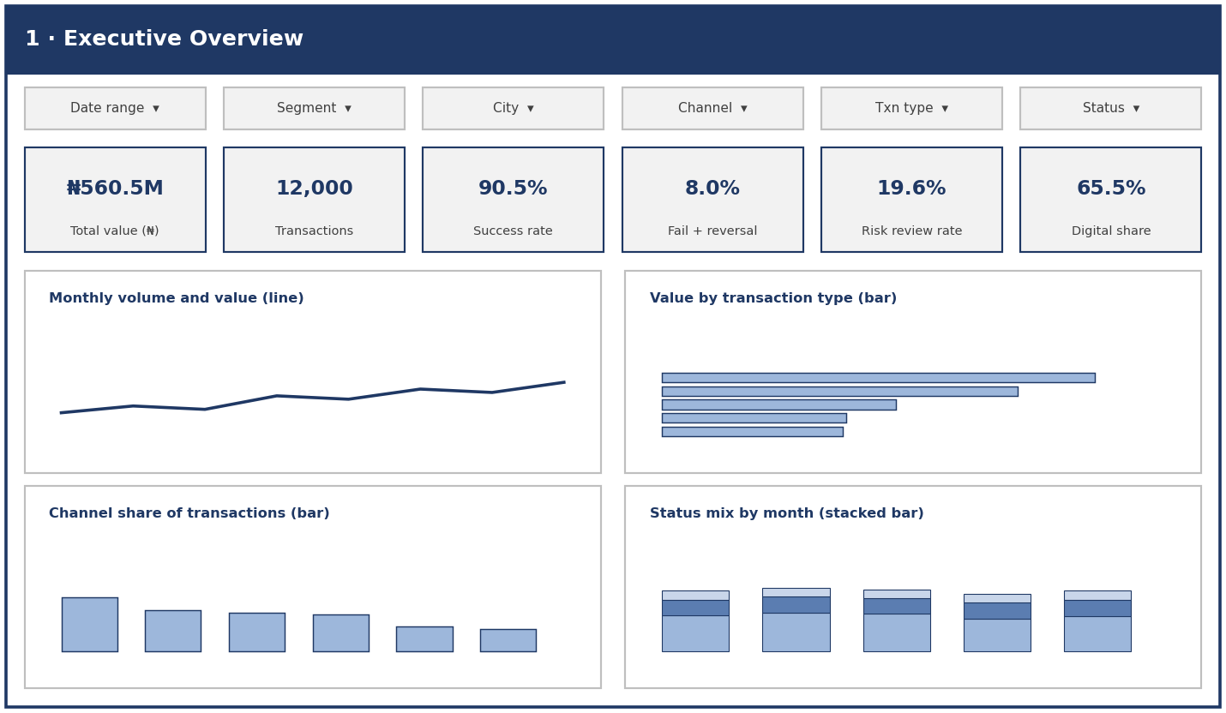

Page 2: Customer Insights
Shows who generates value and how customers behave, by segment, city, income band and engagement.
Expect to show: Lagos and Abuja produce about half of value, engagement score has little link to activity, and 9.1% of transactions come from non-active accounts.
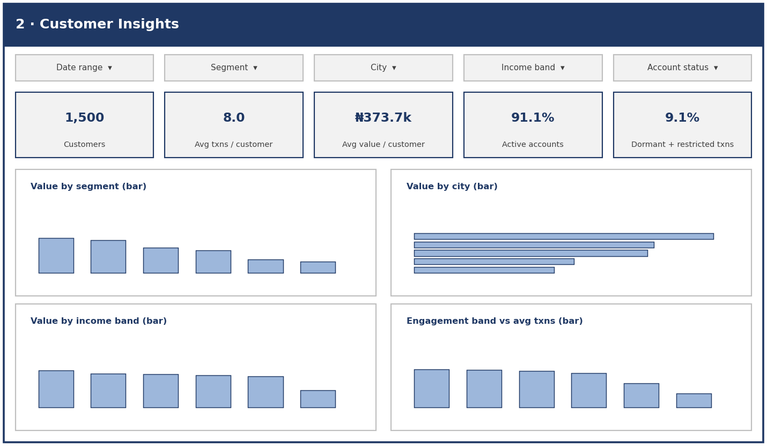

Page 3: Channels and Operations
Compares channel reliability and usage, with failure by device and a data-quality panel.
Expect to show: failure rates are similar across channels (4.2% to 5.8%), Mobile App has the largest absolute failures, and device data is unreliable.
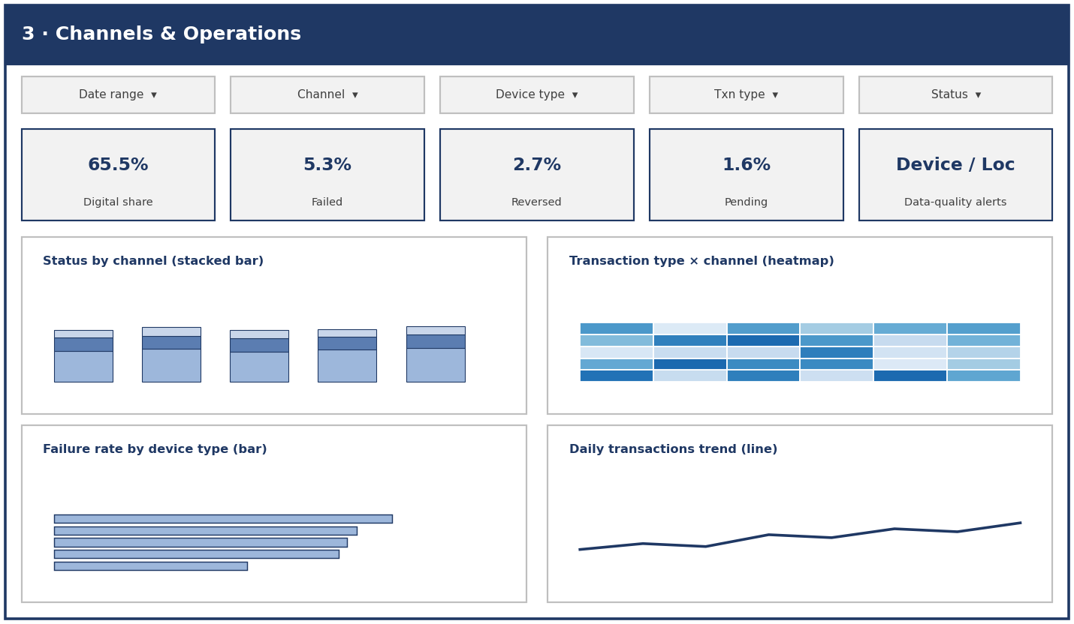

Page 4: Risk Review Patterns
Shows where flagged activity concentrates and how flagged and non-flagged amounts differ.
Expect to show: the flag rate is highest for Transfers, Cash Withdrawals, international transactions and amounts of ₦200k and above.
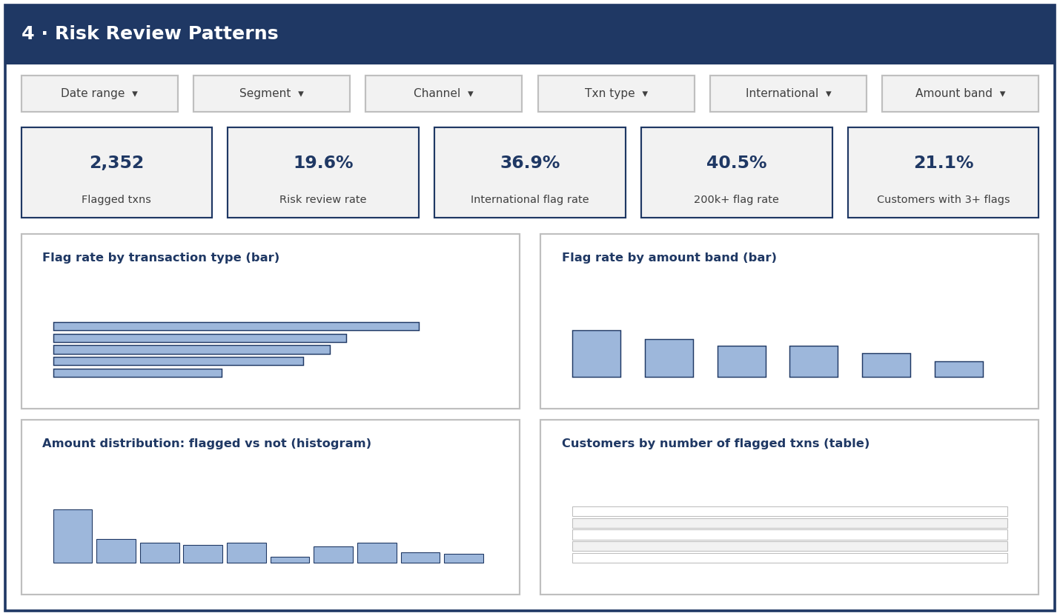

7. Objectives, Success Criteria and Initial Analysis Plan

7.1 Track objectives
- Profile both datasets, document their structure and data-quality issues, and agree cleaning rules by the end of Week 2.
- Answer the seven core analytical questions in SQL and validate results against source counts by the end of Week 2.
- Define and calculate a set of seven KPIs with documented definitions and baseline values.
- Design and build a four-page Power BI dashboard in Week 3, with filters and drill-down.
- Communicate the main insights and data limitations clearly to management and to the other tracks in Week 4.

7.2 Success criteria
- Accuracy: KPI values reconcile with SQL totals and with the row counts (12,000 transactions, 1,500 customers).
- Coverage: the dashboard answers every analytical question and shows all defined KPIs.
- Usability: a non-technical stakeholder can filter and read each page without explanation.
- Documentation: every field, KPI, cleaning rule and limitation is documented.
- Usefulness to other tracks: cleaned data and derived customer features are delivered in a form the Data Science and AI tracks can use.

7.3 Plan for Weeks 2 to 4
Week | Focus | Planned activities | Outputs
Week 2 | Cleaning and analysis | Convert timestamps; label missing Device_Type and Location as Unknown; decide on treatment of outliers and non-active accounts; build customer-level and transaction-level SQL views; calculate all KPIs; run deeper analysis on failures, risk-flag patterns and non-active accounts; share early outputs with other tracks | Cleaned dataset and SQL views, KPI table with final values, analysis notes
Week 3 | Dashboard build | Load views into Power BI; build the four dashboard pages with global and page filters; add tooltips and drill-through; test KPIs against SQL; collect feedback from other tracks | Working Power BI dashboard, KPI validation sheet
Week 4 | Refinement and delivery | Improve visuals and performance; write insight summary and recommendations; document limitations; prepare and rehearse final presentation | Final dashboard, insight report, presentation

Appendix A: SQL Used
Standard SQL. Date-part functions differ slightly by platform. Before the queries, a view converts the date text into a timestamp (PostgreSQL syntax shown).
CREATE VIEW txn AS
SELECT *, TO_TIMESTAMP(transaction_datetime,'MM/DD/YYYY HH24:MI') AS txn_ts
FROM transactions;

Profiling
SELECT COUNT(*) FROM customers; SELECT COUNT(*) FROM transactions;

SELECT COUNT(*)-COUNT(device_type) AS null_device,
COUNT(*)-COUNT(location) AS null_location
FROM transactions;

-- orphan check (expect 0)
SELECT COUNT(*) FROM transactions t
LEFT JOIN customers c ON t.customer_id=c.customer_id
WHERE c.customer_id IS NULL;

-- channel vs device consistency
SELECT channel, device_type, COUNT(*) FROM transactions GROUP BY 1,2 ORDER BY 1,3 DESC;

-- location vs home city
SELECT ROUND(100.0*SUM(CASE WHEN t.location=c.city THEN 1 ELSE 0 END)/COUNT(*),1)
FROM transactions t JOIN customers c USING(customer_id);

Analytical questions
-- Q1 value by segment (repeat for city, monthly_income_band)
SELECT c.customer_segment, COUNT(*) txns, SUM(t.amount_ngn) value, AVG(t.amount_ngn) avg_amt
FROM transactions t JOIN customers c USING(customer_id) GROUP BY 1 ORDER BY 3 DESC;

-- Q2 type and channel
SELECT transaction_type, COUNT(*), SUM(amount_ngn), AVG(amount_ngn) FROM transactions GROUP BY 1 ORDER BY 3 DESC;
SELECT channel, COUNT(*), SUM(amount_ngn), AVG(amount_ngn) FROM transactions GROUP BY 1 ORDER BY 3 DESC;

-- Q3 monthly trend
SELECT DATE_TRUNC('month',txn_ts) m, COUNT(*), SUM(amount_ngn) FROM txn GROUP BY 1 ORDER BY 1;

-- Q4 status rates by channel
SELECT channel, COUNT(*) txns,
ROUND(100.0*SUM(CASE WHEN transaction_status='Failed' THEN 1 ELSE 0 END)/COUNT(*),1) failed,
ROUND(100.0*SUM(CASE WHEN transaction_status='Reversed' THEN 1 ELSE 0 END)/COUNT(*),1) reversed,
ROUND(100.0*SUM(CASE WHEN transaction_status='Pending' THEN 1 ELSE 0 END)/COUNT(*),1) pending
FROM transactions GROUP BY 1 ORDER BY failed DESC;

-- Q5 engagement vs activity
WITH p AS (SELECT c.customer_id,
CASE WHEN digital_engagement_score<50 THEN 'Low' WHEN digital_engagement_score<75 THEN 'Medium' ELSE 'High' END band,
COUNT(*) n, SUM(t.amount_ngn) v
FROM customers c JOIN transactions t USING(customer_id) GROUP BY 1,2)
SELECT band, COUNT(*), AVG(n), AVG(v) FROM p GROUP BY 1;

-- Q6 flag rate by dimension (repeat for channel, transaction_type, transaction_status, international_transaction)
SELECT transaction_type, COUNT(*) txns,
ROUND(100.0*SUM(CASE WHEN risk_review_flag='Yes' THEN 1 ELSE 0 END)/COUNT(*),1) flag_pct
FROM transactions GROUP BY 1 ORDER BY 3 DESC;

SELECT CASE WHEN amount_ngn<10000 THEN '1 Under 10k' WHEN amount_ngn<50000 THEN '2 10k-50k'
WHEN amount_ngn<200000 THEN '3 50k-200k' ELSE '4 200k+' END band,
COUNT(*) txns, ROUND(100.0*SUM(CASE WHEN risk_review_flag='Yes' THEN 1 ELSE 0 END)/COUNT(*),1) flag_pct
FROM transactions GROUP BY 1 ORDER BY 1;

-- Q7 non-active accounts transacting
SELECT c.account_status, COUNT(DISTINCT c.customer_id) customers, COUNT(*) txns, SUM(t.amount_ngn) value
FROM transactions t JOIN customers c USING(customer_id) GROUP BY 1;

KPI baseline
SELECT COUNT(*) total_txns, SUM(amount_ngn) total_value,
ROUND(100.0*SUM(CASE WHEN transaction_status='Successful' THEN 1 ELSE 0 END)/COUNT(*),1) success_rate,
ROUND(100.0*SUM(CASE WHEN transaction_status IN ('Failed','Reversed') THEN 1 ELSE 0 END)/COUNT(*),1) fail_rev_rate,
ROUND(100.0*SUM(CASE WHEN risk_review_flag='Yes' THEN 1 ELSE 0 END)/COUNT(*),1) risk_rate,
ROUND(100.0*SUM(CASE WHEN channel IN ('Mobile App','Web','USSD') THEN 1 ELSE 0 END)/COUNT(*),1) digital_share,
ROUND(100.0*SUM(CASE WHEN international_transaction='Yes' THEN 1 ELSE 0 END)/COUNT(*),1) intl_share,
ROUND(1.0*COUNT(*)/COUNT(DISTINCT customer_id),1) txns_per_customer
FROM transactions;

